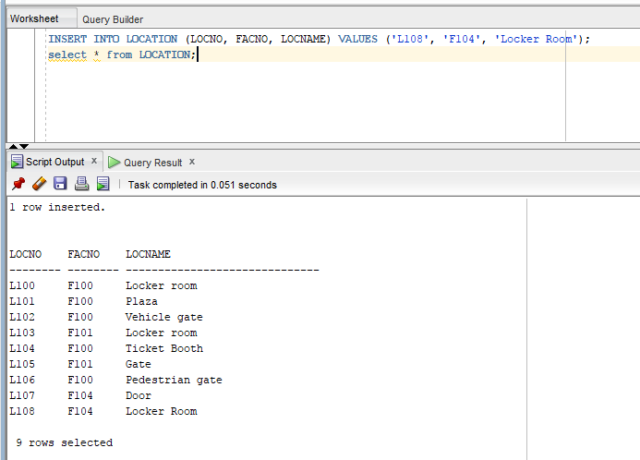
INSERT INTO LOCATION (LOCNO, FACNO, LOCNAME) VALUES (‘L108’, ‘F104’, ‘Locker Room’);
select * from LOCATION;

